Carrier Acquisition

In the different AM modulation methods where a carrier is not transmitted (DSBSC, SSB, … etc), we assumed that the carrier that was used in the transmitter is also available at the receiver. This is a big assumption since it may be easy to generate a sine wave, however, it is difficult to get a sine wave with the SAME FREQUENCY and PHASE as the sine wave that was used in the transmitter. Therefore, the concept of carrier acquisition is important for these types of modulation.

Carrier Acquisition in DSBSC

Since at the input of a DSBSC demodulator system, only the transmitted signal (and random noise) is available, the demodulator must have some method to extract the carrier from the received signal. It is known that the carrier frequency is located at the middle of the DSBSC signal as shown below.
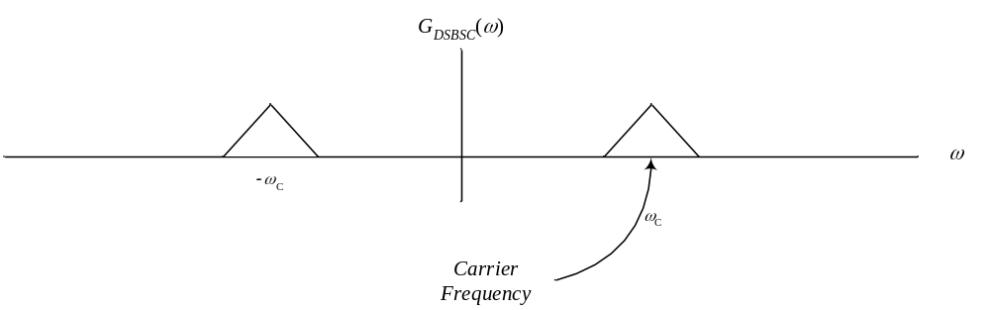
In theory, a filter with an extremely narrowband (few Hz) that is centered at the carrier frequency ω_{c} would be able to extract a signal that represents the carrier frequency. However, this assumes that the message signal has a DC component that when modulated this DC component moves to the carrier frequency. Having a DC component in the message signal that will be modulated using DSBSC is not necessarily the case. In fact, it is generally not the case. Take for example an audio signal. Audio signals do not contain DC since and audio signal travels through the air molecules in the form of variations in the air pressure around the atmospheric pressure. A microphone receives these variations in the air pressure and generates an electric signal with no DC. Also, digital data in the form of binary numbers is generally represented by 1’s and 0’s that have voltages of +5 V and –5 V, respectively. Such a signal generally has no DC. So, in practice, the message signals that are modulated using DSBSC (or other modulation techniques) do not have a DC component as shown in the following figure.

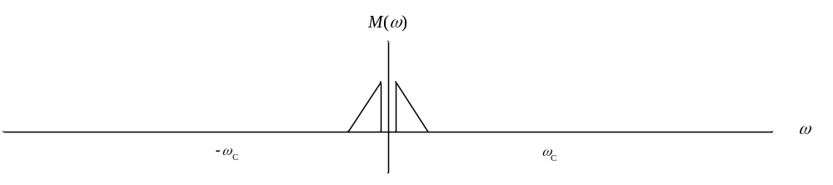

When this signal is DSBSC modulated, we get the following signal
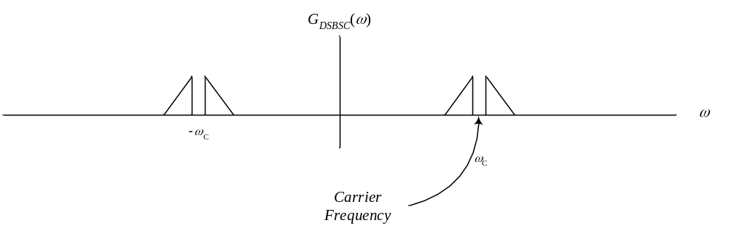
Clearly, in this case, the use of a narrowband BPF to extract the carrier frequency from the modulated signal is not possible because no components in the modulated signal fall at the carrier frequency. Therefore, another method must be used in general.

Signal Squaring Method

The block diagram of this system for extracting a carrier from the received DSBSC signal is shown bellow.

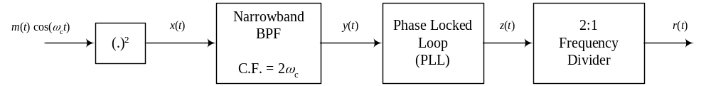

As mentioned earlier, most message signals contain no DC components and therefore their DSBSC modulated signals contain no components at the carrier frequency. However, passing such a DSBSC modulated signal through a squaring device as shown in the block diagram above will give a signal x(t) that is given by
This signal contains a form of the square of the message signal (this is a baseband signal) and the modulation of this signal around twice the carrier frequency. Although m(t) may have no DC component, m²(t) will ALWAYS contain DC since it is always positive.

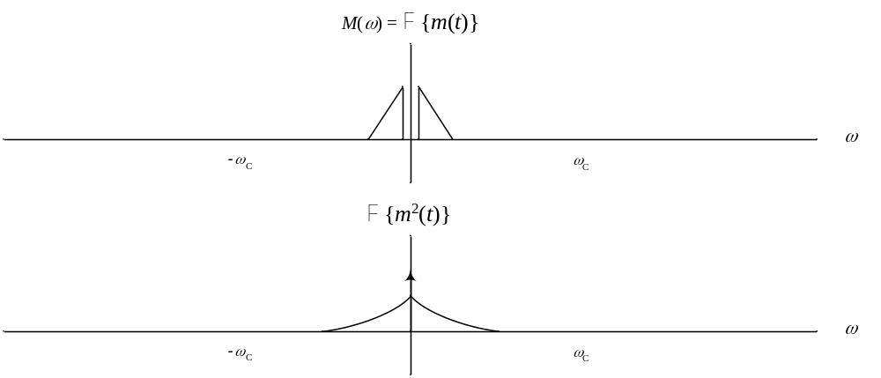
Notice that F{m²(t)} is NOT EQUAL TO M ²(ω) but is equal to the M(ω)*M(ω). So, it has twice the bandwidth of M(ω) and contains a DC component. So, the spectrum of x(t) will be
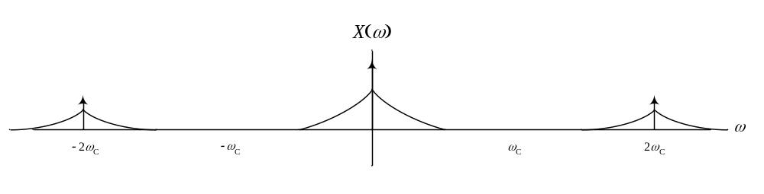Passing this signal through a narrowband BPF with center frequency of 2ω_{c} will pass the sinusoid at that frequency a small part of m²(t).cos(2ω_{c}t) around that frequency. So, the output of the BPF will look like the following.

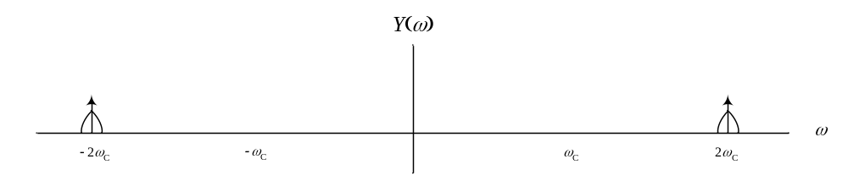To purify the sinusoid with twice the carrier frequency from the remaining part of m²(t).cos(2ω_{c}t), we feed this signal to a phase locked loop (PLL), which produces a sinusoid with the same frequency and phase as that of the sinusoid at the input but rejects the additional signal that represents a distortion (discussion about PLLs will be next). So, the output of the PLL will have the following spectrum.

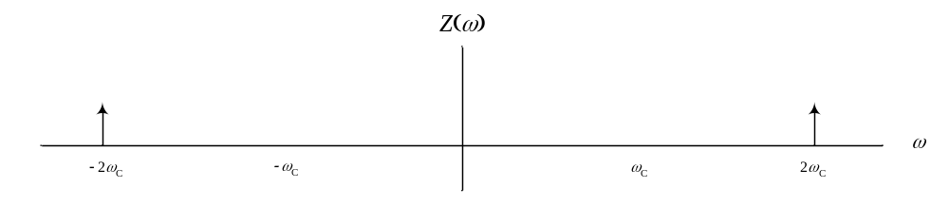
This is a sinusoid with twice the carrier frequency. Passing this signal through a device that divides the frequency of its input signal by two will give a sinusoid with the carrier frequency (the desired signal).
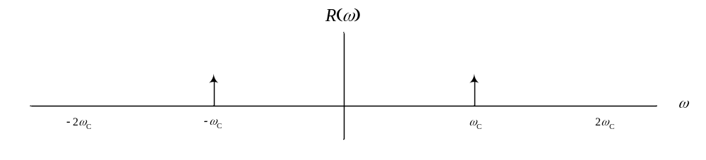

Phase Locked Loop (PLL)

In the block diagram shown above, one of the blocks was a phase locked loop (PLL). The PLL is constructed as shown below.

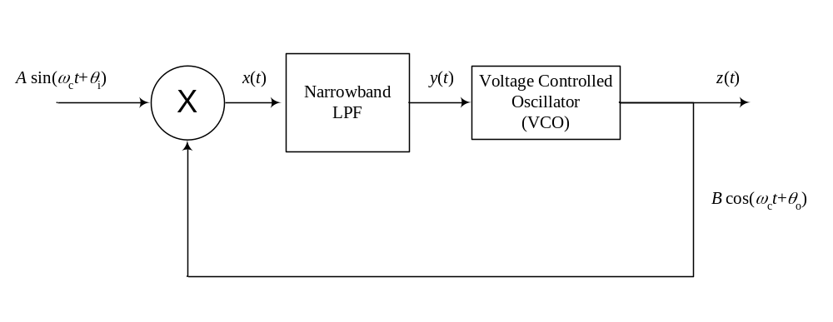

Voltage–Controlled Oscillator (VCO): is a device that produces a sine wave with a frequency that is linearly proportional to the value of the input signal (when the input increases, the frequency of the output increases and vice versa). The frequency of the output of the VCO when the input is zero is called the Free Running Frequency (FRF).

Assuming that the input signal to the PLL is A⋅sin(ω_{c}t+θ_{i}), this signal is multiplied by the output of the PLL. Let us assume that the output of the PLL was at some instant equal to B⋅cos(ω_{c}t+θ_{o}). Therefore, both the input and output have the same frequency but different phases. The signal x(t) becomes

.

The first term in x(t) is a baseband signal since the sine does not contain the carrier frequency. The second component is a high frequency component at twice the carrier frequency. Therefore, the LPF passes the first component and blocks the second component. So, y(t) is

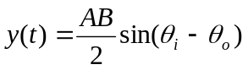.

Now looking at this signal carefully, we see that it is zero when the two angles θ_{i} and θ_{o} are equal. So, assuming that θ_{i} and θ_{o} were equal at some time (θ_{i} = θ_{o}), which means that the signal z(t) is B⋅cos(ω_{c}t+θ_{i}), the signal input to the VCO will be zero. With this, the output of the VCO will be the same signal as what it has been outputting before (i.e., B⋅sin(ω_{c}t+θ_{i})). Now assume that the phase θ_{i} of the input to the PLL started to increase (or started to decrease) slowly such that θ_{i} is slightly greater than θ_{o} (or θ_{i} is slightly less than θ_{o}). The signal z(t) will be a small positive (or negative) value. This signal will force the VCO to speed up (or slow down) and therefore produce a sine wave with an increasing (or decreasing) phase until the phase of the output of the VCO becomes equal to the phase of the input signal. At this moment, the signal z(t) will be zero and this will inform the VCO that it has the same phase as the phase of the input signal so it to stop speeding up (or slowing down) and continue at that frequency and phase.

Characteristics of a PLL

PLL have several characteristics that are summarized as follows:

1. CAPTURE Range of a PLL: every PLL is built to operate in a specific range of frequencies. If the input signal has a frequency in this range, the PLL will be able to capture the phase and frequency of the input signal and start to produce a sine with that frequency and phase.
2. LOCK Range of a PLL: once the PLL has been able to capture a signal and attach its frequency and phase to it, the frequency and phase of the input signal can change and the PLL will still be able to track these changes. The LOCK range of a PLL is always LARGER THAN the CAPTURE range.
3. Noise filtering: if the input to the PLL contains some low–power noise or some low–power distortion that makes the input signal a non–pure sinusoid, PLLs can in general purify the input signal from the noise or distorting signal and produce a very clean sinusoid (So, in the signal squaring method discussed above, inputting the sinusoid with the distortion signal to the PLL produces a pure sinusoid with the same frequency and phase as the input sinusoid).

